# Manual Test

**Reported by:** Vince.

**Component:** WelcomePanel and RegisterFrame

**Version:** Iteration 2, March 10, 2023.

**Configuration:**

On start-up click on the profile icon to navigate to the registration / login to account.

**Problem Descriptions**

**Problem Description 1**: Registering with credentials that already exists in the database does nothing.

INSTRUCTIONS:

1. Click on the profile icon as shown below. Then type
   1. [jane@gmail.com](mailto:jane@gmail.com) : for the email
   2. Janewest : for the username
   3. her5676 : for the password
2. Then click register.

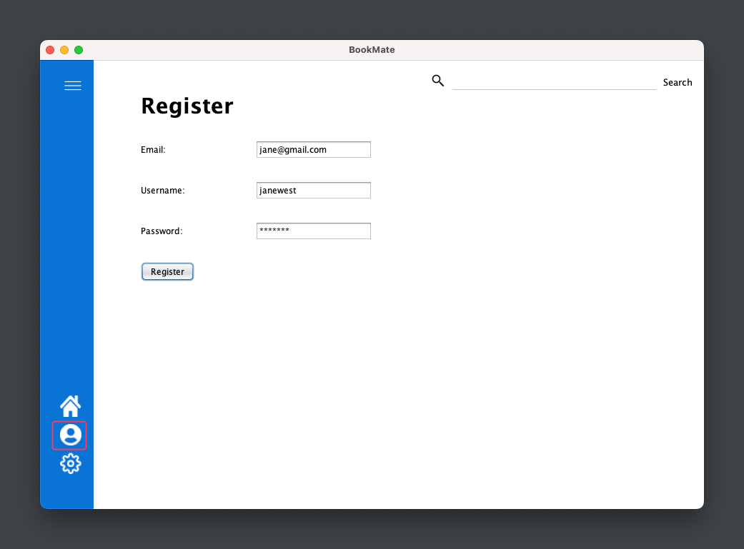

**Problem Description 2**: There is no way to sign out or register for a new Account.

1. Register with a new account that is not in the database or log in with your account.
2. Looking at the current page, which is the Profile page, there is no way to sign out.

For logging in first go to Profile page-> click log in

Now you can type the following;

* Username: janewest
* Password: her5676

Click ‘register’ and the page should redirect to the Profile page that displays the username and the email.

See that there’s no way to sign-out other than to restart the program.

Other cases:

* There is also no way to upload a profile photo and every user is left with the default as shown above.

**Problem Description 3:** Logging in with credentials not that is not in the database does nothing.

Steps are the same as Problem Description 2, but instead typing credentials, username->Gabriel and password -> 12345 does nothing.

Suggested Fix For WelcomePanel and RegisterFrame:

|  |  |  |
| --- | --- | --- |
| Problem Description # | Problem Description | Suggestions |
| 1 | Registering with credentials that already exists in the database does nothing. | Maybe a prompt to the user that username or email already exists. |
| 2 | There is no way to sign out or register for a new Account. | A sign out button or clicking an already existing button |
| 3 | Logging in with credentials not that is not in the database does nothing. | A prompt to the user that username or password is incorrect. Or does not exists. |

Code review

* Domain Object: User
* Logic GoogleJSON
* GUI: RegisterFrame, Template, WelcomePanel